Title of the contribution in the language of the main text. Times 14, bold, centered.

Title of the contribution in the second language (English if the main text is in Spanish or vice-versa) Skip one line before. Times 12, bold, italic, centered.

Author(s): J. Hutton¹, Ch. Lyell² and A. Wegener³ Skip two lines before, Times 10, bold, centered

1 Affiliation of the autor(s) . Full postal address and e-mail address. Skip one line before. Times 8, alignment left
2 Example: Dpto. Geología, Facultad de Geología, Universidad de Oviedo 33005 Oviedo (Asturias). congreso_geologico@uniovi.es

Resumen: Written in Spanish, it must be between 150 and 200 words (10-15 lines, approximately). Authors must take into account that the Resumen/Abstract is the only written document that will appear in the Abstract Volume of the Congress, so they are kindly requested to write a clear and full summary that help attendees fully understand their oral/poster contribution during the congress sessions. Skip two lines before. Times 10, justified. Leave 3 cm at both left and right margins.

Palabras clave: maximum 5 key words in Spanish. Skip one line before. Times 10 justified.

Abstract: Written in English, 150-200 words in length. Skip two lines before. Times 10, italic, justified. Leave 3 cm at both left and right margins. If the contribution is written in English, the fields Abstract/Keywords and Resumen/Palabras Clave should interchange their position and style.

Key words: maximum 5 words. Skip one line before. Times 10, italic, justified.

MAIN TEXT

Skip two lines before. It must be written in Times 10, single line spacing (1 point), justified and arranged in two columns, following this example. We recommend you to keep a safe copy of this template to re-use it if necessary. The length of the main text (including figures, tables, acknowledgments and references) cannot exceed four pages. Leave 2 cm (left and right) and 2,5 cm (top and bottom) margins.

Skip one line before each paragraph and begin it with a 0,5 cm indentation.

The main text should include, as a general rule, the following sections: introduction, previous work, geological setting, data and results, discussion and conclusions. Section titles must be written in UPPERCASE BOLD, with no left indentation and with one line skipped before.



FIGURE 1. (upper case, Times 8). For figure captions use Times 8, italic, justified, with no indentation. Skip one line between the lower edge of the figure and the figure caption. Authors must place the figure captions in the adequate location.

Number figures with Arabic numerals (1, 2, 3, ...) and Tables with Roman numerals (I, II, III, …). Since the contributions are going to be published in electronic format, colour figures and tables are allowed. Authors may wish to place the figures and tables in the document at their convenience. During the final editing process, authors´ choice over placement of figures and tables will be kept if possible. If authors do not have any preference about the exact placement of figures and tables, they may send them at the end of the document in separate pages. We encourage authors to facilitate the editing process and send the figures and tables in their final placement. Figures and tables must be submitted in the final size. They can fit one column width (80 mm) or page width (maximum size is 240 x 170 mm). This template contains two figures, column width (Fig. 1), and page width (Fig. 2), respectively, and one column-wide Table (Table 1). For Figure labeling, it is advisable to use sans-serif fonts (e.g. Arial); they must be large enough to be easily read (we do not recommend using fonts smaller than 8 points). The quality of figures must also be suitable for its final reproduction, we recommend 600 ppi resolution. Figures must be TIFF, EPS or JPG format.

 | COLUMN 2 | COLUMN 3
ROW 2 | 1 | 5
ROW 3 | 2 | 6
ROW 4 | 3 | 7
ROW 5 | 4 | 8

TABLE I. Example of one-column-wide Table. Accompanying text must be Times 8, italic, justified, with no indentation.

ACKNOWLEDGMENTS

A maximum of 6 lines to thank exclusively Search Projects, grants or contracts that have provided funds for the work done.

REFERENCES

The reference section should not contain more than 10 references. References in text must be given as follows:

One author (Wegener, 2007).
Two authors (Hutton y Lyell, 2007).
Three or more authors (Steno et al., 2007).

Include only those references mentioned in the text, listed alphabetically and then by date. The format of the different types of references (journal articles, books, book chapters, geological maps…) must fit the style of the Revista de la Sociedad Geológica de España. The following examples are given as a clue:

Arce Durante, J.M., Fernández Tomas, J. y Monteserín López, V. (1977): Mapa Geológico de España 1:50.000, hoja nº 24 (Mondoñedo). IGME, Madrid.
Córdoba, D., Banda, E. y Ansorge, J. (1987): The Hercynian crust in northwestern Spain: a seismic survey. Tectonophysics, 132: 321-333.
Díaz García, F. (1993): Análisis comparativo de la foliación regional y estructuras asociadas en el Dominio de Santiago y su autóctono relativo. Revista de la Sociedad Geológica de España, 6: 105-114.
Díaz Martínez, E. (1988): El Cretácico Inferior del sector de Jubera (norte de la Sierra de Los Cameros, La Rioja). En: II Congreso Geológico de España. Comunicaciones, 1: 67-70.
Díaz Molina, M. y Tortosa, A. (1996): Fluvial fans of the Loranca Basin, Late Oligocene - Early Miocene, central Spain. En: Tertiary basins of Spain (P. Friend y C. Dabrio, eds.). Cambridge University Press, Cambridge, 292-299.
Schumm, S.A. (1977): The fluvial system. John Wiley & Sons, New York, 338 p.
Vergés, J. (1993): Estudi tectònic del verssant sud del Pirineu central i oriental. Evolució cinemàtica en 3D. Tesis Doctoral, Univ. de Barcelona, 203 p.

Each reference has a hanging indent of 0,5 cm. Do not skip lines between references.

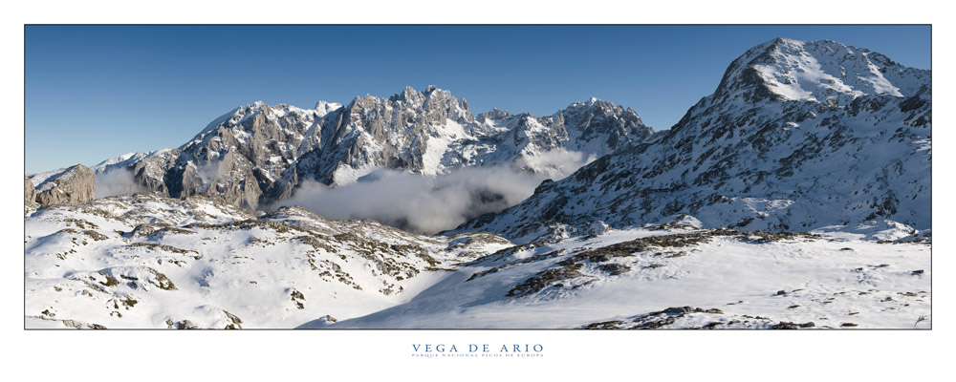

FIGURE 2. Example of figure at page width. If the figure caption is shorter than the page width it must be centered.

